Aerolithium 2000w PORTABLE CHARGER

This series of charger design is a 100% sealed structure type and completely waterproof. It is suitable for all chemistry’s of Lithium batteries. They are used to charge or float charge battery packs in Electric Aircraft applications. Different voltages and current outputs are available.
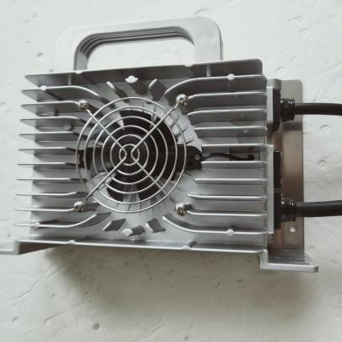
Model | Rated  Voltage for Battery Pack | Max  Output Voltage | Max  Output current
QA-26SNMC-2000W-96V4A | 96.2V | 106.6V | 4A
Input plug : US plug
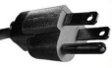
Output plug:Anderson 50a +M8(7mm)

TECHNOLOGY PARAMETERS
AC Input Voltage Range ：90-264VAC；45-65Hz AC Input Max Current : 6A@110VAC
Power Factor ：≥0.99 Efficiency：≥93.0% Noise ：≤45dB Protection ：IP66

PRODUCT CHARACTERISTICS
SAFETY
Active PFC and LLC technique is applied for a rapid
response on a fault; Quick active software self
-protection and reliable passive hardware self-protection on VOLTAGE & CURRENT; Advanced charging strategy is integrated as a safeguard for battery system.

RELIABILITY
The shell is shaped by an integrated die casting
technique and filled with special glue. The active cooling fan is also designed with a potting structure for a longer life. Products of this Charger Series have been operating in all kinds of industrial environment (Wet. Hot. Cold. High altitude) for more than ten years, the design is proved to pass the verification.

FUNCTIONS
Three color indicator lights can be connected externally: charging locking (the vehicle power system can be locked through the dry contact of the relay during charging).

SIZE AND WEIGHT&TEMPERATURE
Net Weight：2.8kg
Operating Temperature：—30℃—65℃ Storage Temperature：—40℃—95℃ Size：231.9*136.5*76

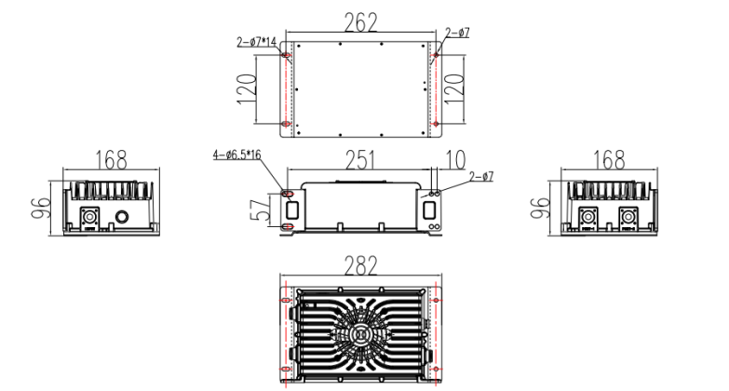

PROTECTION FUNCTIONS
Burnout Protection: If temperature of charger exceeds limitations, the charger will shut down the power load. If temperature of environment exceeds 65 ℃, the charger will stop charging and switch itself to standby mode until temperature of environment goes down.
Protection for Reverse Connection of Batteries: The circuit inside the charger shuts down when the batteries are connected in reverse and will not damage the charger or battery.
NO-load Protection: There is no output when the batteries are not connected.
Short Circuit: The circuit inside the charger shuts down when output is short circuited. The charger will start charging only after troubleshooting and restarting the charger.
Automatic shutdown when fully charged: The charger automatically turns off after the battery is fully charged according to the charger’s judgment.

