Aerolithium 4S /12V/80A BMS Specified for Aircraft Starter LiFePO4 battery
1. Key specification and electrical characteristics:
Item | Condition |  |  |  |  | Unit | Min | Typical | Max
Charge Over Current Protect (COCP) | Max charge current |  |  |  |  | A |  | 100
 | COCP Detect Time (+/-10%) |  |  | = 5Sec |  | A |  | 150
 |  |  |  | =2.5Sec |  | A |  | 200
 |  |  |  | =1Sec |  | A |  | ≧201
 | COCP Release (COCPR) Delay Time |  |  |  |  | 5 |  | 5
Discharge Over Current Protect(DOCP) | Cell voltage range  (Compare with LVSER @ 3.1Vcell) |  | UVP |  |  | V |  | 2.4
 |  |  | OVP |  |  | V |  | 3.85
 | Load Short Circuit Current Protect > |  |  |  |  | A | 900
 | Load Short Circuit Current Protect Delay Time |  |  |  |  | mS |  | 10
 | Short Circuit Protect (SCP) > |  |  |  |  | A |  | 1200
 | Short Circuit Protect (SCP) Delay Time |  |  |  |  | mS |  | ~2
 | Short Circuit Release via checkup every 60S till |  |  |  |  |  |  | Removed
 | Operation time for Over-load Discharge Current Protect per Max Discharge Current, Iout=, +/-10%, @25 ℃, |  |  | 0.3 S |  | A | 800 ~ |  | 900
 |  |  |  | 0.6 S |  | A | 500~ |  | 799
 |  |  |  | 3.0 S |  | A | 300~ |  | 499
 |  |  |  | 7.0 S |  | A | 150~ |  | 299
 |  |  |  | 15 S |  | A | 100 ~ |  | 149
 |  |  |  | 50 S |  |  | 90~ |  | 99
 |  |  |  | 60 S |  | A | 81~ | 89 | 89
 | Continuous Discharge Current (for car starter) |  |  |  |  | A |  | 80
Over Charge Volt Protect (OVP) | OVP (Cell Vmax) |  |  |  |  | V |  | 3.85
 | OVPRelease Voltage ( Cell Vmax ) |  |  |  |  | V |  | 3.55
 | OVP Delay Time |  |  |  |  | Sec |  | .2
LCM display | 12V LCM User Interface(BMS-powered, Option) |  |  |  |  |  |  | option
SM-WO -L=  SleepMode trips ( when without a load in 10 days continuous in quiescence) | Trip  (day base) | With no load for ( or greater than) >= |  |  |  | Day |  | 3 / 72 hrs
 |  | Current draw (No load)= |  |  |  | A |  | 0
 |  | Voltage level (greater than) > |  |  |  | V |  | 3.25
 | Consume | Current in Sleep Mode w/o load |  |  |  | uA |  | 0
 | Wake-up  (release) | 1. Charge with V-in＞V-battery; |  |  |  | V |  | ≧1.5
 |  | 2. press awake button 3 seconds |  |  |  | sec | 3 | Led bright
SM-W-L-1=  Sleep Mode trips, ( with a parasitic load ) | Trigger  (day base) | With a parasitic load for 3 days |  |  |  | Day |  | 3
 |  | Such load with current draw < |  |  |  | A | 1 |  | 8
 |  | Voltage level remains ＞ |  |  |  | V |  | 3.25
 | Consume | Current in Sleep Mode w load |  |  |  | uA |  | 0
 | Wake-up  release | 1. Charge w V-in > V-battery;  2. Press switch 3 sec – led on bright |  |  |  | V |  | ~1.5
 |  |  |  |  |  | Sec | 3
SM-W-L-2 =  LVSER Mode engages, when V  each cell~ 3.25v  and current drain < 8A | Trip( Volt &Current base) | Vcell ≦ |  |  |  | V |  | 3.25
 |  | Current drain @ I-dis＜ |  |  |  | A | 7 | 8 | 9
 |  | Amperes wavering level < |  |  |  | A | 1.5
 | Consume | Current in LVSER mode w a load |  |  |  | A |  | 0
 | Wake-Up (Release) | 1.Press awake switch, and system allows engine start for 60 sec |  |  |  | sec | 60  3.25v
 |  | 2. Charge the battery to uplift volts
LVSER  Self-disabled | 1. Self-disable, while I-dis＞8A, and Vcel < 3.25V  2. Current draw <8A & detect wavering current |  |  |  |  |  |  | Self-  disable
Under Voltage Protect (UVP) | UVP @ V-cell min (v-batt >= 9.6v)= |  |  |  |  | V | 2.37 | 2.40 | 2.43
 | UVP Delay Time |  |  |  |  | Sec |  | 3
 | UVP Release @ from 2.8V till 3.0V in 30 sec |  |  |  |  | V | 2.8 | 3.0
 | UVP Shut-down Current Drain ( batt Vmin 9.6V) |  |  |  |  | u A |  |  | 1
Battery Balance & Balance Mode | Delta Voltage with VH-VL≧40mV @ Vcel≧ |  |  |  |  | V |  | 3.55
 | Balanced Voltage @3.5V or with Delta VH-VL≦ |  |  |  |  | mV | 0 | 15 | 40
 | With PWM current shunt by (25%/50%/75%/100%) |  |  |  |  | m A | 40 |  | 300
 | Balancing Signal via LED Indicator |  |  |  |  |  |  | Luminous
Over Temperature Protect(OTP)// UnderTemperatu-re Protect(UTP) | OTP in Charge as temperature(COTP) |  |  |  |  | ℃ |  | ≧75
 | OTP Release in Charge as temperature (COTPR) |  |  |  |  | ℃ |  | ≦６０
 | UTP in Charging Below 0 (CUTP) |  |  |  |  | ℃ |  | No Limit
 | UTP Release in Charging Below 0 (CUTPR) |  |  |  |  | ℃ |  | No
 | OTP in Discharge as temperature (DOTP) |  |  |  |  | ℃ |  | ≧75
 | OTP Release in Discharge as temperature(DOTPR) |  |  |  |  | ℃ |  | ≦６0
 | UTP in Discharging Below 0(DUTP) |  |  |  |  | ℃ |  | No Limit
 | UTP Release in Charging Below 0 (DUTPR) |  |  |  |  | ℃ |  | No
Bemf conducted | Back Electro-Motive Forces conducted |  |  |  |  | YES | Hardware
Dimension | LWH 156mmx136mmx25mm

2. Feature
1. Continuous discharge current specifically designed for aviation alternator use: 80A
2. Max discharge current: Peak current 900A, with delay time for 10m S. Short circuit >1200A
3. Floating Battery Balancer: smart cell balancer starts at/ over 3.55V, but it acts only on cells with volt variances,
higher by 40mV than the lowest one. The bleeding current dissipates by from 40mA to 300mA,
4. Mosfet Management: Sense circuit designed for purpose of keeping Mosfets from overtemp..
5. Sleep Mode(day base): System shuts off, showing 0 volt measured at pack terminals in 2 conditions.
(a).when it is a status of no load at any voltage level for 3 days.
(b).when it has a light load, where Vcell>3.25, the condition lasts for 3 continuous days.
The way to wake it up is to press / hold the tact switch for 3 sec, which allows starter to work.
6. Low Voltage Start Energy Reserve (LVSER, voltage and current basis):
When cell volt drops down through 3.25V, and current drain is less than 8A, to break off lower current drains,
and to slow down energy loss, LVSER Volt will engage. This function has a voltage range from 3.25V till 2.4V UVP.
7. Sleep Mode and LVSER Mode Disable:
a. Once alternator fails to charge, while the current draw is higher than 8A.
b. If the current drain is < 8A but the detected wavering current is > 2.5A, the LVSER will self-disable.
8. BEMF protection: The BMS has protection for itself conducting back electromotive forces from the load.

3. Physical structure
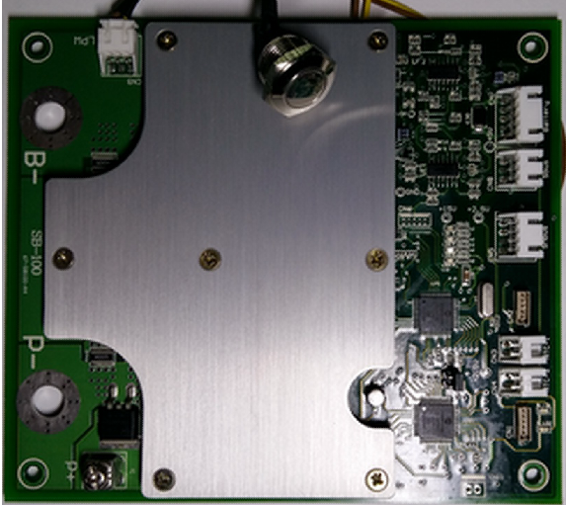

4. Wiring diagram
A LCM module with power source from the main board is available for engineering purpose
(OPTION)..
